**Brooklyn torah gazette**

**For parshas bereishis 5780**

Volume 4, Issue 5 (Whole Number 157) 15-23 Tishrei 5780/ October 14-22, 2019

**Printed L’illuy nishmas Nechama bas R’ Noach, a”h**

For a free subscription, please forward your request to [***keren18@juno.com***](mailto:keren18@juno.com)

**Who will Recite Yizkor for Almoni (the Anonymous Soldier)?**

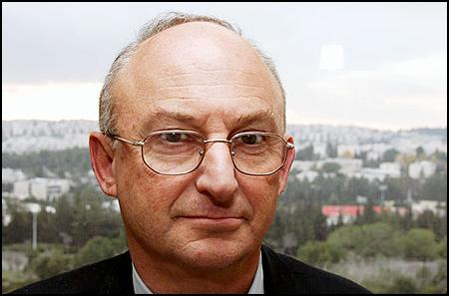

**Aryeh Eldad**

Aryeh Eldad has an interesting and challenging job. He travels to Israeli high schools to help the youngsters transition to a life in the army. It’s not easy for every teen-ager to go from high school into the army. So Eldad travels the country and helps many of these youngsters acclimate themselves to the idea of military service, and primarily, to inspire them to undertake this sacrifice.

As part of his program, he takes the young boys to Mt. Herzel, the cemetery where Prime Ministers, Presidents, and soldiers are interred. He particularly takes them to the military section, where thousands of soldiers are buried. In that cemetery there is a special section for soldiers killed in each war Israel had to fight: a section for 1948, another section for 1956, 1967, 1973, 1982, etc. Eldad always takes his students to these graves, explaining to them the nature of the sacrifices these young men and women made, showing them what these young souls gave up in order to protect their people and their homeland.

In the 1948 section of graves, there is one tombstone which has engraved on it the day the soldier was killed, the location of the battle where he died, and the name of his platoon. But instead of a name, first name and last name, it just says one word: “Almoni.”The anonymous one.

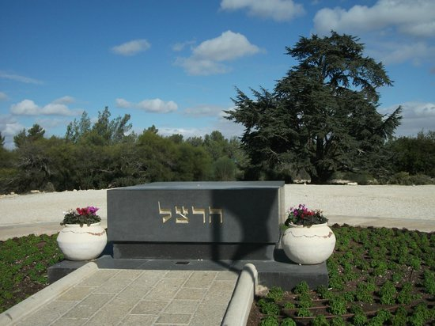

**The Mt. Herzel military cemetery in Jerusalem**

So some time ago, Aryeh Eldad took a group of particularly difficult teen-agers to Mt. Herzel, and then to this grave of Almoni. He shared with them the story of this soldier.

This anonymous fighter was a holocaust survivor. He lost his family in the war. He then came on one of the illegal boats to what was then called Palestine, under the British Mandate. As he arrived in the Holy Land, the war was raging. They told this boy: we need you to fight, to save our people from destruction.

As they retrieved his body for burial and interred this soldier in his grave, they realized the double tragedy. They did not even know the fighter’s name. Not his first name; not his last name. Not his parents’ name. Not where he came from, or which Nazi Camp he survived. The only people who might have known his name, those fighting on his side, also died with him. They had no photo to go ask the people on the boat.

So they buried him and they engraved the title “Almoni.” -The anonymous one.

Eldad went on to explain to these high school boys how 6,000 people died in the War of Independence, out of a population of 600,000, including 4500 soldiers. Ninety percent of the victims were survivors of the Nazi Holocaust who made their way to the Holy Land and died defending it before it was even born.

Aryeh Eldad explained to them how all of these survivors whose families died in the camps had no country that would take them in. From the beginning of World War II, the world was divided into two types of countries: those that expelled or murdered Jews, and those that rejected the Jews who had been expelled or who had fled from elsewhere. Had there been an Israel, there would have been a country willing to take in the Jewish refugees when America, Britain and the other nations refused.

When Pope Paul VI criticized Israel's "fierceness" during a private audience with Golda Meir, she replied: "Do you know what my earliest memory is? A pogrom in Kiev. When we were merciful and when we had no homeland and when we were weak, we were led to the gas chambers."

So, Eldad explained, these survivors gave up their last drop of blood so that Jews would have a place they can call “home,” a place where they need not justify their right to exist as Jews. And some of these young men we don’t even know their names. Almoni.

The boys, seemingly moved, asked their director: Who comes to say kaddish for this young soldier? Who says yizkor for him? Who visits the grave?

And Eldad said: Sadly, nobody. There are no parents, siblings, children, relatives or friends. We can’t even find family, as we do not know his name. But we have come here to pay respects and to recall his sacrifice and glean inspiration from his life and death.

The boys said kaddish at the grave and they continued with their schedule.

These boys were drafted into the Israeli army shortly after. One year later, on the yartziet of this “Almoni,” Aryeh Eldad gets a call. This class of boys, whom he took a year earlier to Mt. Herzl, was on the phone.

“Aryeh, remember the grave of Almoni, that anonymous soldier in Mt. Herzel?”

“Sure!”

“Aryeh, we have found the family of that Almoni soldier! And his family is going today to his grave to say kaddish on this day of his yartziet!’

“You guys are hallucinating. The soldier is dead since 1948. It’s been 70 years. We never found out who he is. How in the world did you find his family? We can’t even do DNA testing, as we do not know who to try to match it up with.’

“Aryeh, we found his family. And from now on, they will be remembering him, doing mitzvot in his memory, saying yizkor for him. We decided that we would become his family. We would adopt him as our family. Each year we will be observing his anniversary of passing.”

Here you have it.

We are his family.

*Reprinted from the Succos 5780 email of the Chabad of Great Neck, NY.*

**The Shmuz onParshas Bereishis**

**Appreciating the Good**

**By Rabbi Bentzion Shafier**

**Founder of TheShmuz.com**

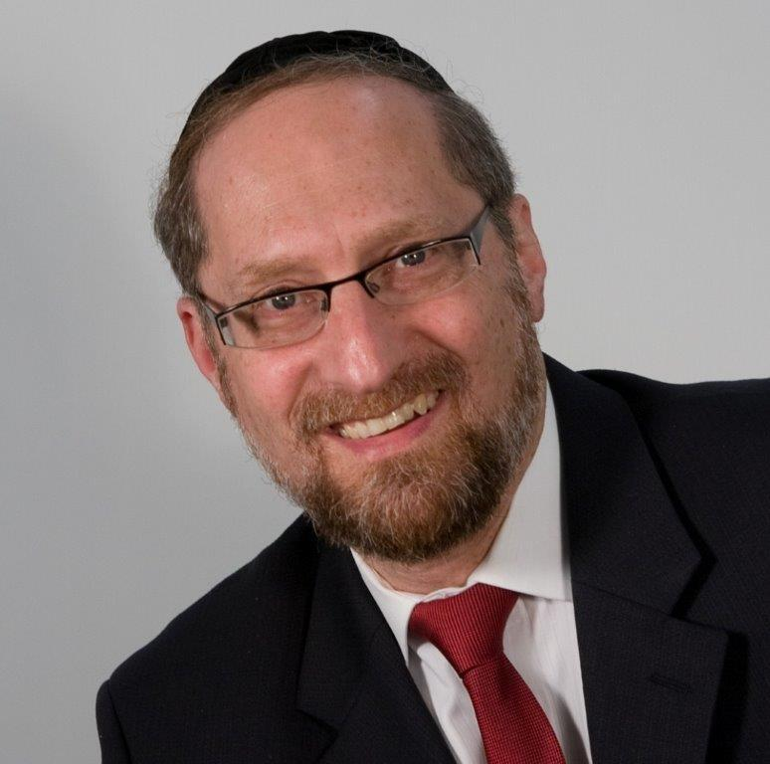

*And Adom said, “The woman that you placed with me, she gave me from the tree and I ate*”. Bereishis 3:12

Adom HaRishon was given one mitzvah: not to eat from the Eitz HaDas. When he transgressed it, HASHEM gave him the opportunity to do Tshuvah. Not only didn’t Adom repent, he played the blame game – “It was that woman that You gave to me. You gave her to me as a helpmate- she turned out to be my ruination.”

Rashi quotes the Gemarah that calls Adom a Kofi Tov, one who denies the good. The Gemarah explains that this is a trait that has plagued mankind from that moment. Instead of appreciating the good, man has continued to deny the very good that is given to him over and over again.

Adom’s claim was logical

The difficulty with this Rashi is that it doesn’t seem that Adom was guilty of denying the good. HASHEM appeared to him and he felt trapped, caught red-handed. The correct action on his part would have been to admit his guilt and beg for forgiveness. That isn’t what he did. Instead, he engaged in small minded, shifting of the blame.

However, there was a logic to it. “Because she was given to me as a helpmate, I relied on her and trusted her.” That fact does mitigate his guilt. After all, no one less than the Creator of the heavens and the earth, gave him this woman as an aide. Surely he could trust HASHEM’s choice.

Adom was guilty of not owning up to his responsibility for the act. Maybe he was guilty of being dishonest. He just wasn’t courageous enough to admit that he did wrong. But his sin wasn’t one of not appreciating the good.

**Appreciating our great wealth**

The answer to this question lies in understanding a different perspective. The Chovos Ha’Levovos gives a parable. Imagine a man who becomes blind at age 35. For the next ten years, he does his best to reconstruct his life, but now without sight. Being a fighter, he struggles to create a productive life for himself. One day, his doctor informs him of an experimental procedure that, if successful, would enable him to see again. He is both frightened and exuberant. If it works he regains his sight; if it fails, he might die.

He gathers together his family to talk it over. After much debate he announces, “I am going ahead with it.” The operation is scheduled. The long-awaited day arrives. Paralyzed with dread, he is wheeled towards the operating room. Given sedatives, he sleeps through the 10-hour operation.

When he wakes up, the first thought on his mind is to open his eyes. He prepares himself for the moment. He will now find out how he will spend the rest of his life. With his family gathered around, with the doctors and nurses at his side, the surgeon begins removing the gauze. The first bandage is off, now the second. The surgeon says, “Open your eyes.” He does. And he sees!

For the first time in ten years, he looks out and experiences the sights of this world – and he is struck by it all. Struck by the brilliance of colors and shapes; moved by the beauty and magnificence of all that is now in front of him. He looks out the window and sees a meadow covered with beautiful, green grass. He sees flowers in full bloom. He looks up and sees a clear, blue sky. He sees people, the faces of loved ones that had only been images in his mind – the sight of his own children whom he hasn’t seen in years. Tears well in his eyes, as he speaks, “Doctor, what can I say? What can I ever do to repay you for what you have given me? This magnificent gift of sight! Thank you!”

This emotion, this extreme joy and sense of appreciation, is something that we should feel regularly. The feeling of elation that man felt when he regained his sight is something that we can feel on a daily basis if we go through the process of training ourselves to feel it. We have this most precious, unparalleled gift called sight, and it is something that we are supposed to stop and think about – not once in a lifetime, not even once a year, but every day. A part of our spiritual growth is learning to appreciate the gifts that we have. One of the blessings we say every morning thanks HASHEM for this most wonderful gift of sight. It was meant to be said with an outpouring of emotion.

We humans are a curious breed. We can have treasures for years, not once thinking of the wealth that we have been given; not once stopping to appreciate them. Not taking a moment to be thankful for them, until something happens, and we lose that gift. Then, it is “HASHEM, why me? Of all the occupants of the planet why did you pick me?” Till then there wasn’t a moment of reflection. Not one thank you. Not even a recognition that it was a gift. Now that it is gone the complaints find their home.

**We fail to see the good**

The reason that we don’t appreciate the good is because we fail to recognize it. It isn’t a problem with appreciation; it is a problem of recognition. By nature we are very appreciative. “If I had any gift, if anyone were to ever do anything for me, I would be the most appreciative person in the world. The problem is that I have nothing. No one ever does anything for me.”

This seems to be the answer to Adom. On some level, he did not recognize the great good that HASHEM had given him in “that woman,” his helpmate. Had he fully recognized the good, he would have felt an overwhelming sense of appreciation, which would have prevented him from saying the words, “That woman that you gave to help me….”

Those words came out because to some extent, he failed to recognize how good she was for him, and therefore he was able to blame her. Had he been fully cognizant of the good, the natural sense of appreciation would have prevented him from making such a statement.

**Improving our lives**

This concept has great ramifications in our lives. Our service to HASHEM should be powered by a tremendous sense of appreciation for the good bestowed upon us. Many of our interpersonal relationships are dramatically weakened because we fail to remember the great good that has been bestowed upon us – by our parents, by our spouses. Ultimately, our lives become so much richer and more enjoyable when we train ourselves to focus on and recognize the good. Our natural sense of appreciation and a desire to pay back the good then wells up within our hearts.

The solution is to take stock, to compare ourselves to others less fortunate, and to recognize the blessings and the good given to us. Once we do that, our natural sense of appreciation flows from our hearts and changes the way we think and act.

*Reprinted from this week’s website on TheShmuz.com This is an excerpt from the*[*Shmuz on the Parsha book*](https://theshmuz.com/product/shmuz-on-the-parsha-book/)*.*

**Thoughts that Count**

*The earth was without form and void, and darkness was on the face of the deep. And the spirit of G-d hovered over the surface of the waters* (Gen. 1:2)

What kind of spirit? "The spirit of King Moshiach" answers the Midrash.

From this we learn an important lesson in our faith.

Our longing for Moshiach must include a yearning for both the first and second stages of Redemption. During the first stage of the Messianic Era, the "yoke of the nations" will be removed from Israel's neck, although the world will continue to exist according to natural law.

The second stage will be marked by open manifestations of G-dliness, such as the resurrection of the dead and other miracles that will be commonplace.

G-d's objective in creating the world, mentioned in the Torah before the creation of man, is the Messianic Era. Our yearning must therefore be for the complete fulfillment of Biblical prophecy and the realization of Divine plan. *(Sichat Parshat Acharei 5746)*

*Reprinted from Issue 336 of L’Chaim Weekly (5755/1994)*

**Rabbi Berel Wein**

**On Bereishith**

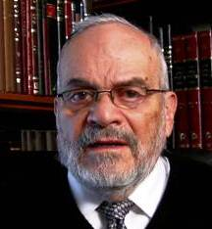

The Garden of Eden is portrayed for us as being the perfect place. Mortality had not yet entered the way of the world and our aged father and mother lived in an environment where everything was provided; food, shelter and freedom from external dangers. Yet, in this most idyllic of situations – one that we cannot begin to contemplate or imagine – temptation lurked even in this setting.

Humans are the union of the body and soul, and as such, perfection cannot be achieved. Humans are destined to always be unsatisfied. We desire foods and pleasures that we do not need, and in fact are not beneficial to us, but we want them just because we haven’t acquired them yet. Once having achieved our goal and desire, so to speak, we are always disappointed and look to find another area of seeming pleasure, in order to satisfy our unquenchable thirst to attain more..

There was a famous comedic skit that was popular in the United States many decades ago about a very wealthy man who built an enormous mansion with many more rooms that he could ever populate or use. Nevertheless, he invited all his friends to the housewarming dedication of his mansion and gave them all a tour of this enormous building. As everyone was showering compliments upon him for having created this monstrosity, he was heard to remark: “This is nothing! Wait to you see the next house that I am going to build for myself.” His Garden of Eden was certainly still not enough.

The rabbis of the Mishnah accurately observed that the more one has, the more worries one acquires. Though Judaism does not preach poverty or asceticism, it does emphasize moderation and for satisfaction not to be found in material items and pleasures alone.

When Adam and Eve were driven from the perfect world that they had originally inhabited and were sent out into the dangerous and less-than-perfect world that we now inhabit, they never lost the original human drive that brought about their expulsion from that perfect world.

Wise men and women throughout the ages have always defined the struggles of society, its wars and decisions, its lack of fairness and the presence of so much evil, as being the futile attempt of humans to try and batter down the gates of that garden and reenter and create a perfect world. The obvious inability of human beings to do so only adds frustration and disappointment. It destroys societies and political systems and destabilizes seemingly great and powerful countries and nations.

But there is an inner voice that reminds us that we do have within us a piece of that perfect world, a system of morality and human goodness, kindness and obedience to the moral code that our Creator has fashioned for us. This enables us to survive and thrive in the imperfect world in which we now live.

*Reprinted from this week’s website of Rabbiwein.com*

**Additional Thoughts for the Parsha**

*And G-d blessed them and said to them, Be fruitful and multiply, and replenish the earth and subdue it* (Gen. 1:28)

The birth of a Jewish child brings joy not only to his parents and extended family but to the entire Jewish people, for it signifies a step closer to the coming of Moshiach.

The Talmud states that Moshiach will not arrive until "all the souls in guf" (the storehouse in which they await their descent into the physical world) have been born.

The birth of a Jewish baby therefore hastens the Redemption and brings closer the blessings of the Messianic Era. *(Sichat 25 Iyar, 5743)*

*Reprinted from Issue 336 of L’Chaim Weekly (5755/1994)*

**The Torah is an Eternal Guide Book for the Jewish People**

**From the Talks of the Lubavitcher Rebbe**

**Rabbi Menachem Mendel Schneerson, Zt”l**

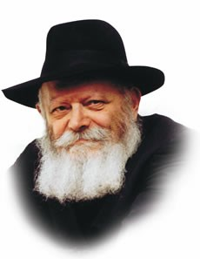

"In the beginning G-d created the heaven and the earth." With these momentous words the Torah begins the very first chapter of Bereishis, establishing G-d's Kingship over all of creation.

The Torah, however, is not history book. The Torah is the guide by which we live our lives, applying its teachings to every aspect of our existence.

The ancient Sage, Rabbi Yitzchak, raises a pertinent question.

"Why does the Torah open with the story of Creation?" he asks, as quoted by Rashi in his commentary. "Why didn't G-d begin with the words, 'This month is to you,'-- the first commandment containing practical implications?"

"The might of His deeds He told to His nation; to bequeath to them the heritage of the nations," Rabbi Yitzchak himself answers.

"If the nations of the world will one day accuse the Jewish people of being thieves, having 'stolen' the land of Israel from the seven nations who formerly inhabited it, they will counter, 'The entire earth belongs to G-d! He is the One Who created it and bequeathed it to whom He saw fit. It was His will to give the land to the nations; it was His will to take it from them and give it to us."

According to this explanation, the entire order of the Torah's portions was changed solely to refute the world's complaint that the Jewish people misappropriated their land. But is their accusation really so important that G-d would change even one letter in His holy Torah for its sake? Would not a refutation in the Oral Tradition have been sufficient to counter whatever complaint Gentiles would one day lodge against the nation of Israel?

In truth, the Torah's choice of language holds significance not only for the nations of the world but for Jews themselves.

"In the beginning" contains an important lesson for every Jew to apply in his daily life.

In general, the life of a Jew may be divided into two realms: the religious and the secular.

The Jew willingly observes his various religious obligations because the Torah requires him to.

When, however, he is asked to also sanctify those mundane aspects of daily existence that seemingly fall outside the domain of religious observance, he balks, rejecting this demand as an invasion of privacy.

The secular realm of a person's life, pertaining to the physical and material domain, metaphorically belong to the "seven nations."

Yet it is precisely this realm that the Jew is called upon to conquer, elevating his every action by performing it solely for the sake of heaven.

"You are thieves!" the world cries out against the Jew. "How dare you conquer the domain of the seven nations and blur the distinction between religious observance and the mundane?!"

To which the Jew replies, "All of creation belongs to G-d." Every realm of existence is part of Divine plan and can be made holy.

Indeed, such is the mission of every Jew -- to transform wherever he may be into a spiritual Land of Israel.

Judaism demands that we sanctify even the lowest aspects of the material world, thereby imbuing all of creation with holiness and demonstrating the unity of the One Creator. *Adapted from Likutei Sichot of the Rebbe, Vol. XX*

*Reprinted from the Issue #336 of L’Chaim Weekly (Parashat Bereishit 5755/1994)*

**Rav Avigdor Miller on**

**Living for Hashem**

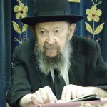

**QUESTION:** What does it mean when we ask Hashem for life and we say למענך אלקים חיים - "Let us live for Your sake Hashem"?

**ANSWER**: The words למענך אלקים חיים, for Your sake *Elokim chayim,* mean more than one thing. But one important thing is this. Hakodosh Boruch Hu wants to give us a great gift, the gift of knowing about Him.

Now, the fact that you believe in Hashem is very nice. But it's not enough. It's too weak; it's too pale. Hakodosh Boruch Hu wants us to think about Him and know Him more than that. And therefore, when Hashem gives us any favor, any form of kindliness, one of the purposes – actually the most important purpose – is so that we should say, "Oh, Hashem, now we see that You are kind. You're so good to us and we thank You for that."

That's why a beautiful peach is given such a fine color, a blush on each cheek. Why is the peach so beautifully colored? Besides for tasting good inside, why is it so beautifully colored? Because Hashem wants you to enjoy the peach even more.

And why does Hashem want you to enjoy it? You're supposed to enjoy the peach so that you can thank Hashem: "Oh Hashem, I thank You for this peach. Thank You Hashem." That's the purpose – to thank Him. "Hashem, You're זן את העולם כולו, You feed the whole world; but not only do You give us food, but You do it בחן בחסד וברחמים. You do it with kindliness."

And as we are learning about the kindliness of Hashem, we are gaining more and more knowledge of Hashem. The more you appreciate what Hashem does for you, the more you gain knowledge of Hashem's kindliness. And that is a tremendous benefit for us.

And therefore we say, "For Your sake Hashem, give us life." "For your sake," means, "You Hashem want us to learn about You, because that's our success in this world. So give us a happy life, and we promise You Hashem, that this coming year we're going to utilize every day to say, 'Thank You Hashem for today.'

Today we began the seventh day of the new year! "Oooh, we thank You Hashem." Seven days already! Seven days! Are you thanking Hashem?! Right now, thank Him. Right now! It's already seven days. Soon it will be seventy days. Soon it'll be three hundred and sixty five days. Soon it'll be Rosh Hashana again. Did you thank Hashem for that yet? Every year it comes, and you forget to thank Hashem.

So your first obligation is to thank Hashem for what He did for you already. When you use your life to thank Hashem, that's למענך, that's living for Your sake, Hashem. You want us to know about You and the more we enjoy what You give us, we're going to think about You more and understand You more.

So the coming year, when you eat, you say, "Ahh, I thank You Hashem for the good bread." When we wash with soap, we thank Hashem for the soap: "Ahh, soap is such a wonderful thing." You drink water, you thank Hashem. You take a bath, you thank Hashem. You put on clothing, you thank Hashem for the clothing. You breathe the air, you thank Hashem for the air.

"Oh, now I see that you know how to live," Hashem says. "That's living for My sake. I'm giving you these things for My sake, so that you should appreciate who I am. And that's your success in this world!"

Hashem says, "That's your success in life. If you would understand that I am the *mekor* *ha'chesed*, the source of all kindliness in the world, then that's called living for My sake. Then you're living for Me and that's what I want from you." That's למענך אלקים חיים.  TAPE # E-201 (Sept 1999)

*Reprinted from the October 7, 2019 email of Toras Avigdor adapted from Tape #E-201 (September 1999).*

**Rabbi Eli J. Mansour**

**On Parashat Bereishit**

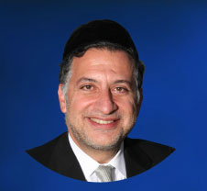

The first verse of the Torah tells us that G-d created the world "Bereishit," which we generally interpret to mean "in the beginning." Rashi, however, comments that the letter "Bet" in the word "Bereishit" can also mean "for the sake of," in which case this verse should be read as, "G-d created heaven and earth for the sake of 'Reishit'."

"Reishit" ("the first"), Rashi explains, refers to Am Yisrael and to the Torah, both of which are called "Reishit" elsewhere in Tanach. Thus, according to Rashi, the opening verse of the Torah informs us that G-d created the universe – the galaxies, the planets, the entire natural order – specifically so that the Jewish people could study Torah.

This message is conveyed later in the Parasha, as well. In concluding the narrative of each day of creation, the Torah mentions the number of that day – "Yom Echad" ("one day"), "Yom Sheni" ("the second day"), "Yom Shelishi" ("the third day"), and so on.

In concluding the sixth and final day of creation, however, the Torah refers to that day as "Yom Ha'shishi" ("the sixth day"), adding the letter "Hei" for emphasis. The Torah then writes, "The heavens and the earth and all their array was completed."

The Rabbis explain that the Torah alludes here to the famous "sixth day" of Sivan in the year 2448 after creation, the day on which the Torah was given to Benei Yisrael at Sinai. Only at that point, after this special "sixth day," was the creation complete. Since the entire purpose of creation is the study of Torah, the process of creation cannot be said to have been completed until the Torah was presented to mankind. The Torah therefore emphasizes that on "Yom Ha'shishi," on the day of Matan Torah, the heavens and the earth were complete.

Because of this, the Zohar writes that were there to be no Torah study in the world for even a single moment, the world would cease to exist. Since the world was created purely for the sake of Torah learning, the cessation of learning would automatically result in the world's destruction.

Torah is like the world's oxygen; the universe cannot exist for an instant without it.  It is like the gasoline needed for a car engine to run, and the electricity required for an appliance or machine. A car cannot run on an empty gasoline tank, even for a moment, and a machine cannot operate without the constant flow of an electric current. Similarly, the world cannot be sustained for even a single instant without the study of Torah.

The Sages tell us that when G-d came to give Benei Yisrael the Torah, He suspended Mount Sinai over their heads and threatened to destroy them should they refuse to accept the Torah. If an ill patient needs an oxygen machine to survive, the physician does not first ask him if he wishes to be hooked up to the machine; he enters the room and turns on the machine with or without the patient's consent. Similarly, G-d did not give Benei Yisrael the choice whether or not to accept the Torah. Since the survival of the entire universe depended on their acceptance, He forced it upon them.

The beginning of a new Torah reading cycle is an appropriate time to recommit ourselves to the study of Torah, the greatest of all the Mitzvot. Understanding that the very survival of the world and all its inhabitants hinges on Torah learning, we must reaffirm our devotion to learning, to participating in Torah classes and encouraging others to do the same, so that we successfully fulfill the task assigned to Am Yisrael to sustain the world and all its inhabitants through our study of Torah.

*Reprinted from this week’s website of the Edmond J Safra Synagogue of Brooklyn website.*

**Hundreds Stranded in**

**New York as El Al Flight Misses Takeoff Time**

**By Dror Halavy**

[](https://images.hamodia.com/hamod-uploads/2019/01/24164801/French-Court-Rules-Against-El-Al-in-Compensation-Case-1024x680.jpg)**An El Al airline plane at Ben Gurion Airport. (Moshe Shai/Flash90)**

**YERUSHALAYIM** -

Hundreds of Israelis, as well as foreign residents who planned to spend Simchas Torah in Israel will have to find alternate plans – in New York, where they are stuck for the Yom Tov*.* An El Al flight that was set to land in Israel Sunday afternoon failed to take off on time on Motzoei Shabbos, because of damage to the plane.

The new Boeing 787 was damaged as luggage was loaded onto the plane. The damage was repaired a short time later, but by the time the plane was cleared for a new flight plan, it appeared that the plane might not make it before Yom Tov*.* Rather than take a chance, El Al decided to postpone the flight until after the end of Yom Tov*.*

As a result, airline staff has been busy booking alternative accommodations for travelers. As many of them are observant, El Al has been working to book those without places to stay in the New York area in hotels where they will be able to observe the Yom Tov*,* such as hotels that allow guests to use keys instead of keycards, and are located near shuls and sources of kosher food.

In a statement, El Al said that “as a result of damage due to loading of luggage, we were unable to carry out flight 008 from New York as planned. All travelers are being taken care of by our representatives and are being transferred to hotels. We apologize to our customers for the unpleasantness, and wish everyone a *chag sameach.*”

*Reprinted from the October 20, 2019 website of Hamodia.*

**More Thoughts that Count**

*In the beginning (bereishis) G-d created the heaven and the earth* (Gen. 1:1)

Our Sages tell us that the entire world was created solely for the sake of the two things that are called "reishis" ("first") -- Israel and the Torah.

Speaking about the Messianic Era, the Prophet Isaiah said, "The nation and the kingdom that does not serve you will be destroyed."

When Moshiach comes the nations of the world will lend aid and support to the Jewish people, recognizing that their very existence depends on their service; those who refuse to accept their subservient position will disappear from the face of the earth. *(Likutei Sichot Vol. XXIV)*

Although the Torah mentions the creation of heaven, its emphasis is clearly on earth, for that is where man is destined to fulfill his G-dly role.

*(Rabbi Shimshon Refael Hirsch)*

*Reprinted from Issue 336 of L’Chaim Weekly (5755/1994)*